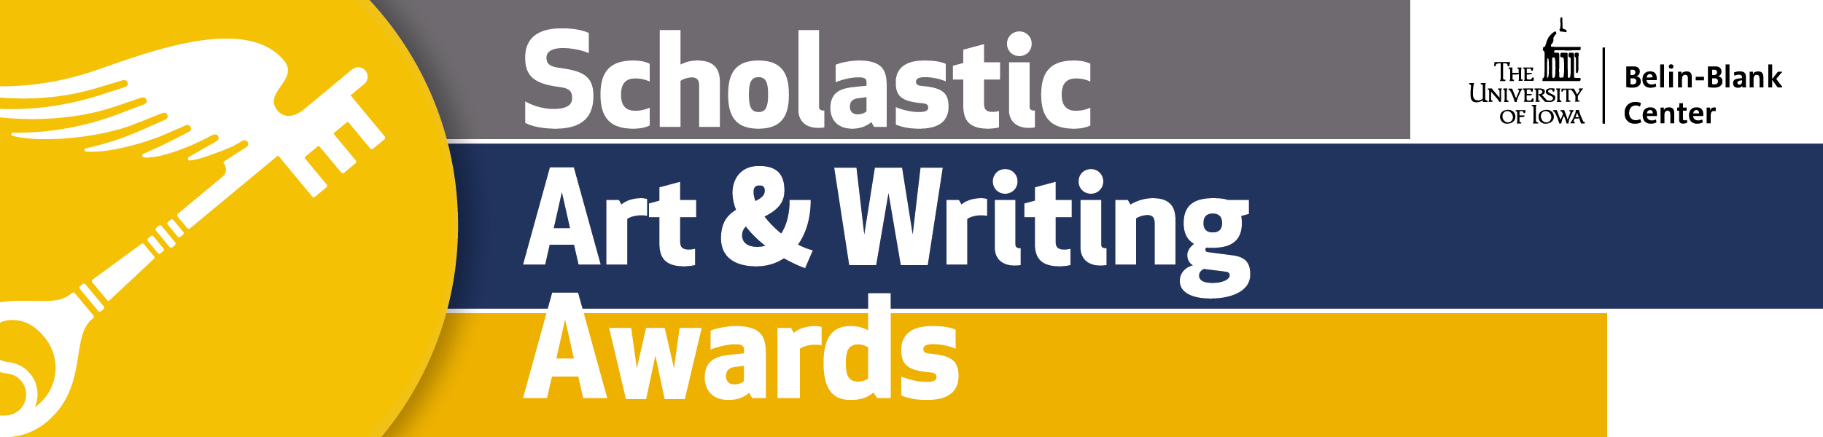

[Town/City/Region] Student[s] Announced as 2020 Regional Scholastic Art & Writing Award Recipient[s]

[XX] Young [Artist[s]/[and Writer[s]] Recognized by the University of Iowa’s Belin-Blank Center for [his/her/their] Original Works

[CITY, STATE] — [Date] — The Belin-Blank Center at the University of Iowa has announced the regional award recipients of the 2020 Scholastic Art & Writing Awards. Presented by the nonprofit organization, the Alliance for Young Artists & Writers, the Scholastic Art & Writing Awards are the country's longest-running and most prestigious scholarship and recognition program for creative students in grades 7–12. This program year, more than 330,000 works of art and writing were submitted to 100 Affiliate regions across the country. As one of the largest national affiliates, the Belin-Blank Center adjudicated over 7,000 pieces of art and writing from the Iowa and Midwest Regions. Creative teens from Iowa and the Midwest received regional honors, including Gold Keys, Silver Keys, Honorable Mentions, and/or American Visions & Voices nominations, including:

[INSERT LIST OF LOCAL STUDENT NAMES, AGES, AWARD TITLES HERE]

Since the program’s founding in 1923, the Awards have fostered the creativity and talent of millions of students, including renowned alumni who have gone on to become leaders in their fields, including Andy Warhol, Truman Capote, Richard Avedon, Philip Pearlstein, and Sylvia Plath. More recently, Stephen King, Richard Linklater, Zac Posen, and Lena Dunham received Scholastic Art & Writing Awards when they were teens.

For Gold Key works of art and writing in the Awards’ 29 categories, including architecture, painting, flash fiction, poetry, printmaking, video game design, and more, the opportunities for recognition will continue when those works are adjudicated again on a national level by a panel of leading creative professionals. National Gold Medalists will be announced in March 2020 and will be honored during a special awards ceremony at the world-famous Carnegie Hall in New York City in June 2020. All National Medal recipients are eligible for a wealth of additional opportunities, such as inclusion in the Art.Write.Now.Tour traveling exhibition, which will be hosted by the University of Iowa’s Belin-Blank Center this coming fall. National Medalist poets are considered for the National Student Poets Program, the nation’s highest honor for young poets presenting original work.

A complete list of 2020 regional Scholastic Art & Writing Awards Gold Key recipients is available online at
artandwriting.org.

“The Belin-Blank Center Presents: A Scholastic Celebration in Three Acts” on Saturday, March 7 at the
University of Iowa’s Iowa Memorial Union. For more information about the Celebration, go to www.belinblank.org/scholastic.

For more information about the Alliance for Young Artists & Writers and the Scholastic Art & Writing Awards,
visit the Scholastic News Room: http://mediaroom.scholastic.com/artandwriting.

###

